PROJECT PROPOSAL
Web-Based Citizen Complaint Management System for Adama City Administration

Field | Detail
Project Title | Web-Based Citizen Complaint Management System
Organization | Adama City Administration
Document Version | 2.15
Date | 22 August 2026
Prepared By | ____________________ (ID: __________)
Institution | Haramaya University — College of Computing and Informatics, Department of Information Science
Supervisor / Advisor | ____________________
Host Organization | Adama City Administration Science and Technology Office

Declaration
I hereby declare that this project proposal, titled "Web-Based Citizen Complaint Management System for Adama City Administration", is my original work. It has been prepared as part of the academic requirements of Haramaya University, College of Computing and Informatics, Department of Information Science under the guidance of my advisor.
I further declare that:
• This work has not been submitted, in whole or in part, for any other degree, diploma, or academic award at this or any other institution.
• All sources of information used in this document have been properly acknowledged through citations and references.
• The system design, documentation, and implementation described herein represent work carried out by me, except where otherwise stated.
| | |
|--|--|
| Name | ____________________ |
| ID | __________ |
| Signature | ______________________________ |
| Date | ____________________ |

Acknowledgement
First and foremost, I would like to thank Almighty God for the strength, guidance, and opportunity to complete this project proposal.
I express sincere gratitude to my advisor for continuous guidance, constructive feedback, and encouragement throughout the preparation of this document and the development of the system.
I also thank the instructors and staff of the Department of Information Science, College of Computing and Informatics, Haramaya University for the knowledge and support provided during the course of study.
Special appreciation is extended to Adama City Administration Science and Technology Office as the host organization for this work, and to colleagues, classmates, and family members who offered advice, motivation, and moral support.
Finally, I acknowledge all authors, developers, and organizations whose published works, documentation, and open-source tools contributed to the completion of this proposal.

Abstract (Executive Summary)
Municipal complaint handling in Adama City Administration has traditionally relied on paper-based processes and office visits. This approach causes delays, weak record keeping, limited status tracking, and reduced transparency between citizens and responsible departments.
This project implements a Web-Based Citizen Complaint Management System to digitize submission, assignment, tracking, and reporting of citizen complaints. The system supports three roles: Citizen, Administrator, and Department Officer. Citizens can register, submit categorized complaints (Adama area, optional landmark and photo), edit pending complaints, and track progress using unique reference numbers. Administrators manage users and departments, assign work, update status, and generate reports. Officers process assigned tasks within their department scope and add resolution notes.
The solution is built with the MERN stack (MongoDB, Express.js, React, Node.js), using JWT authentication and role-based access control. Optional AI assistance (writing help, triage, resolution drafts, chatbot) runs as a sidecar service. Status history, in-app notifications (marked seen when opened), and email alerts (real mailboxes only) improve accountability and communication.
Keywords: citizen complaint, e-governance, Adama City Administration, MERN, role-based access control
Implementation snapshot (August 2026)
The delivered application is complaints-only. A parallel service-request module was removed so citizens, admins, and officers work from one complaint workflow. Location is selected from Adama sub-cities, kebeles 01–18, and landmarks, with an optional extra detail field. Authenticated screens are localized in English, Amharic, and Afaan Oromo. Opening the notifications page marks items as seen automatically. Demo logins (*@test.com) do not receive email. The Activity Log stores assignment details with department and officer names (not database IDs).

Table of contents
Declaration ................................................................ i
Acknowledgement ............................................................. ii
Abstract (Executive Summary) ................................................ iii
List of Acronyms ............................................................ iv
CHAPTER ONE: INTRODUCTION ................................................... 1
1.1 Background of the Study ............................................. 1
1.2 Problem Statement ................................................... 2
1.3 Objectives .......................................................... 2
1.3.1 General Objective ............................................. 2
1.3.2 Specific Objectives ........................................... 2
1.4 Scope of the Project ................................................ 3
1.4.1 In Scope ...................................................... 3
1.4.2 Out of Scope .................................................. 3
1.4.3 Complaint-only scope .......................................... 3
1.5 Limitations ......................................................... 4
1.6 Literature Review and Related Work .................................. 4
CHAPTER TWO: SYSTEM REQUIREMENTS AND DESIGN ................................. 5
2.1 Proposed System ..................................................... 5
2.1.1 Citizens Can .................................................. 5
2.1.2 Administrators Can ............................................ 5
2.1.3 Department Officers Can ....................................... 6
2.2 Actors of the System ................................................ 6
2.2.1 Citizen ....................................................... 6
2.2.2 Administrator ................................................. 6
2.2.3 Department Officer ............................................ 6
2.3 Functional Requirements ............................................. 7
2.3.1 Complaint Categories (Predefined) ............................. 7
2.3.2 Location (Adama) .............................................. 7
2.3.3 Status Values ................................................. 7
2.3.4 Status Transition Rules (Implemented) ......................... 8
2.4 Non-Functional Requirements ......................................... 8
2.4.1 Security ...................................................... 8
2.4.2 Performance ................................................... 8
2.4.3 Reliability ................................................... 9
2.4.4 Usability ..................................................... 9
2.4.5 Scalability ................................................... 9
2.4.6 Maintainability ............................................... 9
2.5 System Architecture ................................................. 10
2.6 Use Case Diagram .................................................... 10
2.7 Entity-Relationship Diagram ......................................... 11
2.8 Data Flow Diagram (Level 0) ......................................... 12
2.9 System Workflow ..................................................... 12
2.10 Technology Stack and Development Tools ............................. 13
2.11 Database Design .................................................... 13
2.11.1 Collections Overview ......................................... 13
2.11.2 Users Collection ............................................. 14
2.11.3 Departments Collection ....................................... 14
2.11.4 Complaints Collection ........................................ 14
2.11.5 Status Histories Collection .................................. 15
2.11.6 Notifications Collection ..................................... 15
CHAPTER THREE: METHODOLOGY AND PROJECT PLAN ................................. 16
3.1 Methodology ......................................................... 16
3.2 Project Timeline .................................................... 17
3.2.1 Gantt Chart ................................................... 17
3.3 Testing Strategy .................................................... 18
3.3.1 Sample Test Cases ............................................. 18
3.4 Deployment Plan ..................................................... 19
3.4.1 Environment Setup ............................................. 19
3.4.2 Deployment Architecture ....................................... 19
3.4.3 Deployment Steps .............................................. 20
3.4.4 Minimum Server Requirements ................................... 20
CHAPTER FOUR: RESULTS AND DISCUSSION ........................................ 21
4.1 Results ............................................................. 21
4.1.1 Public Portal and Authentication .............................. 21
4.1.2 Citizen Modules ............................................... 22
4.1.3 Officer Modules ............................................... 23
4.1.4 Administrator Modules ......................................... 24
4.2 Discussion .......................................................... 25
4.3 Expected Benefits ................................................... 26
4.3.1 For Citizens .................................................. 26
4.3.2 For Adama City Administration ................................. 26
4.4 Expected Outcome .................................................... 27
4.5 Future Enhancements ................................................. 27
CHAPTER FIVE: CONCLUSION .................................................... 28
References .................................................................. 29
Document Revision History ................................................... 30

List of Acronyms
Acronym | Full Form
AM | Amharic
API | Application Programming Interface
CORS | Cross-Origin Resource Sharing
CRUD | Create, Read, Update, Delete
CSS | Cascading Style Sheets
DFD | Data Flow Diagram
EN | English
ER | Entity-Relationship
FK | Foreign Key
FR | Functional Requirement
GIS | Geographic Information System
HTML | HyperText Markup Language
HTTP | HyperText Transfer Protocol
HTTPS | HyperText Transfer Protocol Secure
ID | Identifier
JSON | JavaScript Object Notation
JWT | JSON Web Token
MERN | MongoDB, Express.js, React, Node.js
ODM | Object Document Mapper
OM | Afaan Oromo
PK | Primary Key
RBAC | Role-Based Access Control
REST | Representational State Transfer
SLA | Service Level Agreement
SMS | Short Message Service
SPA | Single-Page Application
SSL | Secure Sockets Layer
UAT | User Acceptance Testing
UI | User Interface
UK | Unique Key
URL | Uniform Resource Locator
VPS | Virtual Private Server
XSS | Cross-Site Scripting

CHAPTER ONE: INTRODUCTION
1.1 Background of the Study
Adama City Administration provides various municipal services to citizens. Citizens often need to submit complaints regarding public services such as road maintenance, waste management, water supply, street lighting, and other community-related issues. In addition, citizens may request different municipal services from the city administration.
Currently, many complaints are handled manually through paper-based processes or office visits. This leads to:
• Delays in service delivery
• Poor record management
• Limited tracking capabilities
• Reduced transparency between citizens and administration
To address these challenges, a web-based system is implemented to allow citizens to submit complaints online, track their progress in real time, and receive feedback from responsible departments.

1.2 Problem Statement
The existing complaint management process faces several challenges:
• Manual handling of complaints and requests
• Difficulty in tracking complaint status
• Delayed response from responsible departments
• Lack of centralized data storage
• Poor communication between citizens and city administration
• Limited reporting and monitoring capabilities
• Inefficient record management
• No audit trail for status changes
• No standardized categories for complaints and service types

1.3 Objectives
1.3.1 General Objective
To develop a web-based citizen complaint management system for Adama City Administration that improves transparency, efficiency, and accountability in municipal service delivery.

1.3.2 Specific Objectives
• To provide online citizen registration and secure authentication (including email password reset)
• To enable citizens to submit complaints electronically with category, Adama location, optional landmark, and optional photo
• To allow citizens to edit pending complaints before they are assigned
• To provide complaint tracking with status history and unique reference IDs
• To provide role-based administrative and department dashboards
• To improve communication through in-app notifications and optional email
• To generate reports and statistics for decision-making
• To maintain centralized, searchable records of complaints
• To support department-based assignment and processing workflows
• To offer optional AI assistance for drafting, triage, and FAQ (suggestions only)

1.4 Scope of the Project
1.4.1 In Scope
• User registration and login (JWT authentication) with email password reset
• Complaint submission with category, Adama area dropdown, optional landmark, and optional photo
• Citizen edit of pending complaints
• Status tracking with history (Pending, In Progress, Resolved, Rejected, Closed)
• Role-based access: Citizen, Administrator, Department Officer
• User management (Administrator: view users, activate/deactivate)
• Department management (Administrator: list and add departments)
• Complaint assignment to departments and optional officers
• Search and filter complaints (admin lists; citizens view their own)
• In-app notifications; opening the notifications page marks them seen
• Role-specific dashboards with summary statistics
• In-app report summaries (counts by status, category, department)
• Activity/audit log for administrative actions
• Multi-language UI (English, Amharic, Afaan Oromo) for public and authenticated screens
• Optional AI assist (citizen writing, admin triage, officer resolution draft, chatbot)
• Email notifications to real mailboxes (demo @test.com addresses are skipped)
• Success feedback (submission popup; action toasts)
1.4.2 Out of Scope
• Online payment processing
• Advanced GIS mapping and interactive maps (Adama area list is used instead)
• Live SMS to real phones (Africa’s Talking sandbox is available but off by default)
• Native mobile applications (web-responsive only in this phase)
• Full user/department CRUD (edit/delete), complaint delete, and report export
• JWT refresh tokens, API rate limiting, and list pagination (planned hardening)
• A separate service-request workflow (removed from the implemented system)
1.4.3 Complaint-only scope
Earlier drafts distinguished complaints (report a failure) from service requests (ask for a new service). The implemented system records municipal issues as complaints only, so routing, tracking, and reporting stay on one path. Guest “municipal services” cards on the landing page describe issue categories; they are not a second request form.

1.5 Limitations
• Requires internet access; citizens without connectivity must still use offline channels
• Initial deployment assumes manual setup of departments and officer accounts by administrators
• File uploads limited to images (including JPEG, PNG, WebP, GIF) up to 2 MB per attachment
• Demo accounts (citizen@test.com, admin@test.com, officer@test.com) are for login only and do not receive email
• No integration with existing legacy paper records
• Performance targets assume moderate concurrent usage (up to 500 simultaneous users)

1.6 Literature Review and Related Work
Several municipal and e-governance systems demonstrate the value of digital complaint management:
System / Study | Approach | Relevance
FixMyStreet (UK) | Web-based geo-tagged reporting | Shows citizen-driven reporting improves response times
311 Systems (USA) | Centralized non-emergency service requests | Model for categorization and department routing
Ethiopian e-Service initiatives | Government digital transformation | Aligns with national push for digital public services
CRM-based municipal portals | Role-based dashboards and ticketing | Supports assignment, tracking, and reporting workflows

Gap identified: Adama City Administration lacks a dedicated, centralized web platform that connects citizens, administrators, and department officers with transparent status tracking and reporting. This project fills that gap using a modern MERN stack suitable for rapid development and scalability.

CHAPTER TWO: SYSTEM REQUIREMENTS AND DESIGN
2.1 Proposed System
The proposed system is a web-based application accessible through modern browsers. It follows a three-tier architecture: React frontend, Node.js/Express API, and MongoDB database.
2.1.1 Citizens Can
• Create accounts and manage profiles (name, phone)
• Log in securely with JWT-based sessions; reset password by email
• Submit complaints with category, Adama location, optional landmark, description, and optional photo
• Use optional AI writing assist and browser voice input on the complaint form
• Edit a complaint while it is still pending
• View and track status of their complaints (with reference ID)
• Receive in-app notifications (marked seen when the notifications page is opened)
• View their own complaints from the citizen dashboard
2.1.2 Administrators Can
• View users and activate/deactivate accounts
• Add departments and view department list
• View all complaints (search/filter)
• Assign complaints to departments and optionally to officers
• Use optional AI triage suggestions when routing
• Reject pending complaints; resolve/close in-progress items
• View report summaries and dashboard analytics
• Monitor system activity via audit logs
2.1.3 Department Officers Can
• View personally assigned items and unassigned items in their department queue
• Start work (Pending → In Progress)
• Add resolution notes
• Mark tasks as Resolved or Closed (officers cannot reject)
• View officer dashboard statistics

2.2 Actors of the System
2.2.1 Citizen
Responsibilities: Register account, log in, submit complaints, edit pending complaints, view status, update profile, receive notifications.
2.2.2 Administrator
Responsibilities: View and activate/deactivate users, add departments, assign submissions, update/reject statuses, view report summaries, monitor system activities.
2.2.3 Department Officer
Responsibilities: View assigned work and department queue, process complaints, update progress, add notes, mark tasks resolved or closed. Each officer belongs to one department (e.g., Water, Roads, Sanitation). Officers cannot reject submissions.

2.3 Functional Requirements
ID | Requirement | Description
FR-01 | User registration | Citizens register with full name, email, phone, and password
FR-02 | User login | Authenticate with email and password; receive JWT token
FR-03 | Profile management | Update name and phone; view account role
FR-04 | Complaint submission | Submit with title, description, category, Adama location, optional landmark, optional photo
FR-05 | Edit pending complaint | Citizen updates a complaint only while status is pending
FR-06 | Status tracking | View current status and full status history timeline
FR-07 | Dashboard | Role-specific dashboards with counts and recent items
FR-08 | User management | Admin lists users and activates/deactivates accounts
FR-09 | Department management | Admin lists and adds departments
FR-10 | Assignment | Admin assigns submission to department; optional officer
FR-11 | Report summaries | View counts by status, category, and department
FR-12 | Search | Admin search/filter by reference ID, keyword, and status
FR-13 | Notifications | In-app notifications on assignment and status change
FR-14 | Audit log | Record who changed status and when
FR-15 | Success feedback | Confirm successful submissions and admin/officer actions

2.3.1 Complaint Categories (Predefined)
Road Maintenance, Waste Management, Water Supply, Street Lighting, Drainage, Public Safety, Noise Pollution, Other.
2.3.2 Location (Adama)
Required area key from sub-cities (Lugo, Dabe, Bole, Dembela, Aba Geda, Hawas), kebeles 01–18, or landmarks (Medhanialem, Adama Stadium, Central Bus Station, China Avenue, ASTU, Wonji). Optional landmark / street text (max 120 characters) is stored separately.
2.3.3 Status Values
Status | Description
Pending | Submitted; awaiting review or sitting in a department queue
In Progress | Assigned to an officer and being processed
Resolved | Issue addressed or service fulfilled
Rejected | Invalid or out of scope (admin only)
Closed | Closed without further action

2.3.4 Status Transition Rules (Implemented)
Role | From | Allowed next statuses
Officer | Pending | In Progress
Officer | In Progress | Resolved, Closed
Admin | Pending | Rejected
Admin | In Progress | Resolved, Closed, Rejected
Admin | Resolved | Closed

Assignment note: Routing to a department only keeps status Pending. Assigning (or claiming) an officer moves the item to In Progress.

2.4 Non-Functional Requirements
2.4.1 Security
• Password hashing with bcrypt (never store plain text)
• JWT authentication with configurable expiration (no refresh tokens in Phase 1)
• Role-based access control (RBAC) on API routes and frontend routes
• HTTPS in production
• Input validation and sanitization (prevent XSS, injection)
• Secure file upload validation (type and size; max 2 MB)
• Rate limiting on login and submission endpoints (planned hardening)
2.4.2 Performance
• API response time under 2 seconds for typical requests
• Indexed database queries on status, citizenId, departmentId, createdDate
• List pagination (planned; Phase 1 returns role-scoped full lists)
2.4.3 Reliability
• Consistent operation with structured error handling
• Automated MongoDB backups (daily in production)
• Graceful degradation when optional features (e.g., file upload) fail
2.4.4 Usability
• Responsive design for desktop and mobile browsers
• Clear navigation and accessible forms with validation messages
• Consistent UI patterns across citizen, admin, and officer interfaces
• Success popups/toasts after key actions
• Multi-language support on the public guest experience (EN/AM/OM)
2.4.5 Scalability
• Stateless API design for horizontal scaling
• MongoDB Atlas replica sets as user base grows
2.4.6 Maintainability
• Modular code structure (routes, controllers, models, middleware)
• API exercises via HTTP client tools (e.g., Postman / Thunder Client)
• Version control with Git and GitHub

2.5 System Architecture
Figure diagram 1 (see source Markdown if image did not render).
flowchart TB
subgraph Client["Client Layer"]
Browser["Web Browser (React SPA)"]
end

subgraph Server["Application Layer"]
API["Node.js + Express REST API"]
Auth["JWT Auth Middleware"]
RBAC["Role-Based Access Control"]
AI["Optional AI sidecar"]
end

subgraph Data["Data Layer"]
MongoDB[(MongoDB Database)]
Storage["File Storage (uploads/)"]
end

Browser -->|HTTPS / JSON| API
Browser -.->|Assist / chat JSON| AI
API --> Auth
Auth --> RBAC
RBAC --> MongoDB
API --> Storage
Figure 2.1: System architecture — complaint portal with optional AI sidecar
2.6 Use Case Diagram
Figure diagram 2 (see source Markdown if image did not render).
%%{init: {
"theme": "base",
"themeVariables": {
"fontSize": "15px",
"fontFamily": "Arial",
"primaryColor": "#FFFFFF",
"primaryTextColor": "#111111",
"primaryBorderColor": "#003366",
"secondaryColor": "#E8EEF7",
"tertiaryColor": "#FFFFFF",
"lineColor": "#222222",
"clusterBkg": "#F7FAFC",
"clusterBorder": "#003366",
"titleColor": "#003366",
"mainBkg": "#FFFFFF",
"nodeBorder": "#003366",
"edgeLabelBackground": "#FFFFFF"
},
"flowchart": {
"nodeSpacing": 22,
"rankSpacing": 55,
"padding": 16,
"htmlLabels": true,
"curve": "basis",
"useMaxWidth": true
}
}}%%
flowchart LR
Citizen((Citizen))

subgraph System["Web-Based Citizen Complaint Management System"]
direction TB

UC_Register([Register Account])
UC_Login([Login])
UC_SubmitComplaint([Submit Complaint])
UC_EditComplaint([Edit Pending Complaint])
UC_Track([Track Complaint Status])
UC_Profile([Update Profile])
UC_Notify([View Notifications])

UC_Users([Manage Users])
UC_Depts([Manage Departments])
UC_Assign([Assign Complaints])
UC_Update([Update Status])
UC_Reports([Generate Reports])
UC_Activity([Monitor System Activities])
UC_Search([Search and Filter Complaints])

UC_Tasks([View Assigned Tasks])
UC_Process([Process Assigned Work])
UC_Note([Add Resolution Note])
end

Admin((Administrator))
Officer((Department Officer))

Citizen --- UC_Register
Citizen --- UC_Login
Citizen --- UC_SubmitComplaint
Citizen --- UC_EditComplaint
Citizen --- UC_Track
Citizen --- UC_Profile
Citizen --- UC_Notify

Admin --- UC_Login
Admin --- UC_Users
Admin --- UC_Depts
Admin --- UC_Assign
Admin --- UC_Update
Admin --- UC_Reports
Admin --- UC_Activity
Admin --- UC_Search
Admin --- UC_Notify

Officer --- UC_Login
Officer --- UC_Tasks
Officer --- UC_Process
Officer --- UC_Update
Officer --- UC_Note
Officer --- UC_Notify

UC_SubmitComplaint -.->|include| UC_Login
UC_EditComplaint -.->|include| UC_Login
UC_Process -.->|include| UC_Update
UC_Assign -.->|include| UC_Update
Figure 2.2: Use case diagram — citizen, administrator, and officer (complaints only)
2.7 Entity-Relationship Diagram
Figure diagram 3 (see source Markdown if image did not render).
erDiagram
USER ||--o{ COMPLAINT : submits
USER ||--o{ NOTIFICATION : receives
USER ||--o{ ACTIVITY_LOG : performs
USER }o--|| DEPARTMENT : "belongs to (officer)"
DEPARTMENT ||--o{ COMPLAINT : "assigned to"
COMPLAINT ||--o{ STATUS_HISTORY : has

USER {
ObjectId _id PK
string fullName
string email UK
string passwordHash
string role
string phoneNumber
ObjectId departmentId FK
boolean isActive
datetime createdAt
datetime updatedAt
}

DEPARTMENT {
ObjectId _id PK
string name UK
string description
boolean isActive
datetime createdAt
}

COMPLAINT {
ObjectId _id PK
string referenceId UK
string title
string description
string category
string location
string landmark
string status
ObjectId citizenId FK
ObjectId departmentId FK
ObjectId assignedOfficerId FK
string photoUrl
string attachmentUrl
string resolutionNote
datetime createdAt
datetime updatedAt
datetime resolvedAt
}

STATUS_HISTORY {
ObjectId _id PK
string entityType
ObjectId entityId FK
string fromStatus
string toStatus
string note
ObjectId changedBy FK
datetime changedAt
}

NOTIFICATION {
ObjectId _id PK
ObjectId userId FK
string title
string message
string relatedEntityType
ObjectId relatedEntityId
boolean isRead
datetime createdAt
}

ACTIVITY_LOG {
ObjectId _id PK
ObjectId userId FK
string action
string entityType
ObjectId entityId
string details
datetime createdAt
}
Figure 2.3: Entity-relationship diagram — users, departments, and complaints
Figure diagram 4 (see source Markdown if image did not render).
flowchart LR
Citizen[Citizen]
Admin[Administrator]
Officer[Department Officer]
System((Web System))
DB[(Database)]

Citizen -->|Complaint| System
Citizen -->|Login / Track| System
Admin -->|Manage / Assign / Report| System
Officer -->|Process / Update| System
System --> DB
DB --> System
System -->|Status / Notifications| Citizen
System -->|Dashboard / Reports| Admin
System -->|Assigned Tasks| Officer
Figure 2.4: Level-0 data flow — complaints, assignment, and status feedback

2.9 System Workflow
Figure diagram 5 (see source Markdown if image did not render).
flowchart TD
A[Citizen registers and logs in] --> B[Submit complaint with category, Adama location, and details]
B --> C{Citizen edits while pending?}
C -->|Yes| B
C -->|No, leave submitted| D[System stores record as Pending]
D --> E[Administrator reviews complaint]
E --> F{Valid?}
F -->|No| G[Status: Rejected]
F -->|Yes| H{Assign how?}
H -->|Department only| I[Status stays Pending - department queue]
H -->|Department + officer| J[Status: In Progress]
I --> K[Officer starts work]
K --> J
J --> L[Department officer processes]
L --> M{Outcome?}
M -->|Fixed| N[Status: Resolved]
M -->|Close| O[Status: Closed]
N --> P[Citizen notified and views update]
O --> P
G --> P
Figure 2.5: Complaint workflow from submit/edit through assignment and resolution
Step-by-step:
1. Citizen registers an account and logs into the system.
2. Citizen submits a complaint (category, Adama area, optional landmark and photo). While it is Pending, the citizen may edit it.
3. System generates a unique reference ID (e.g., CMP-2026-0001) and stores the record as Pending.
4. Administrator reviews the complaint.
5. Administrator either rejects it, routes it to a department queue (Pending), or assigns an officer (In Progress).
6. Department officer processes the complaint (start work if still pending) and may add resolution notes.
7. Officer sets Resolved or Closed; admin may also reject in-progress items.
8. Status history and audit log are recorded; citizen views progress and notifications.

2.10 Technology Stack and Development Tools
Layer | Technology | Purpose
Frontend | React.js (Vite), HTML5, CSS3, JavaScript | Single-page user interface
UI / Client | React Router, native fetch | Routing and API communication
Backend | Node.js, Express.js, Helmet | REST API server
Database | MongoDB Atlas (or local), Mongoose | Document storage and ODM
Authentication | JWT, bcrypt | Secure sessions and password hashing
Validation | express-validator | Request validation
File Upload | multer | Complaint image attachments
i18n | Custom language context | English, Amharic, Afaan Oromo (public and authenticated UI)
Email | Nodemailer SMTP / Resend | Assignment and status emails; @test.com skipped
AI | Optional Express sidecar | Gemini / OpenAI / heuristic suggestions
Development | Visual Studio Code, Git, GitHub | Coding and version control

Note on database choice: MongoDB supports flexible schemas for complaints. Relational integrity is enforced at the application layer via Mongoose references. PostgreSQL is a viable alternative if strict relational reporting is required later.

2.11 Database Design
2.11.1 Collections Overview
Collection | Purpose
users | All system users (citizens, admins, officers)
departments | Municipal departments
complaints | Citizen complaint records
statusHistories | Status change audit trail
notifications | In-app user notifications
activityLogs | Administrative action logs

2.11.2 Users Collection
Field | Type | Description
_id | ObjectId | Primary key
fullName | String | User full name
email | String | Unique email (login)
passwordHash | String | Bcrypt-hashed password (not plain text)
role | Enum | citizen, admin, officer
phoneNumber | String | Contact number
departmentId | ObjectId | FK to departments (officers only)
isActive | Boolean | Account enabled/disabled
createdAt | Date | Registration date
updatedAt | Date | Last profile update

Indexes: email (unique), role, departmentId
2.11.3 Departments Collection
Field | Type | Description
_id | ObjectId | Primary key
name | String | e.g., Water Supply, Roads
description | String | Department description
isActive | Boolean | Active flag
createdAt | Date | Created date

Indexes: name (unique)
2.11.4 Complaints Collection
Field | Type | Description
_id | ObjectId | Primary key
referenceId | String | Human-readable ID (e.g., CMP-2026-0001)
title | String | Short title
description | String | Full description
category | Enum | Predefined category
location | String | Adama area key (sub-city, kebele, or landmark)
landmark | String | Optional street / nearby place
status | Enum | pending, in_progress, resolved, rejected, closed
citizenId | ObjectId | FK to users
departmentId | ObjectId | FK to departments
assignedOfficerId | ObjectId | FK to users (optional)
photoUrl | String | Optional photo (data URL or path)
attachmentUrl | String | Optional uploaded file path
resolutionNote | String | Officer/admin resolution text
createdAt | Date | Submission date
updatedAt | Date | Last update
resolvedAt | Date | Resolution timestamp

Indexes: referenceId (unique), citizenId, departmentId, status, createdAt
2.11.5 Status Histories Collection
Field | Type | Description
_id | ObjectId | Primary key
entityType | Enum | complaint
entityId | ObjectId | FK to complaint
fromStatus | String | Previous status
toStatus | String | New status
note | String | Optional comment
changedBy | ObjectId | FK to users
changedAt | Date | Timestamp

2.11.6 Notifications Collection
Field | Type | Description
_id | ObjectId | Primary key
userId | ObjectId | FK to users
title | String | Notification title
message | String | Notification body
relatedEntityType | String | complaint
relatedEntityId | ObjectId | Related record ID
isRead | Boolean | Read flag
createdAt | Date | Created timestamp

Indexes: userId, isRead, createdAt

CHAPTER THREE: METHODOLOGY AND PROJECT PLAN
3.1 Methodology
This project follows an Agile-inspired iterative development approach suited for a academic/software engineering project:
Phase | Activities
1. Requirements | Gather requirements, define scope, document actors and use cases
2. Design | Architecture, ER diagram, API design, UI wireframes
3. Implementation | Backend API first, then frontend integration, feature by feature
4. Testing | Unit, integration, and user acceptance testing
5. Deployment | Deploy to staging, then production server
6. Documentation | User manual, API docs, final report

Development order (recommended):
1. Project setup and database models
2. Authentication and user management
3. Complaint create/list/update APIs
4. Assignment and status workflow
5. Notifications and audit log
6. Dashboard and reports
7. Testing and deployment

3.2 Project Timeline
Estimated duration: 12 weeks
Implementation status (as of August 2026): Core MERN complaint system delivered (API, role UIs, Atlas DB, photo upload, Adama location dropdown, pending edit, EN/AM/OM i18n, email + password reset, optional AI sidecar). Remaining work focuses on hardening, live SMS, GIS, and production deployment.
Week | Phase | Tasks | Deliverables
1 | Planning | Finalize requirements, proposal, ER diagram | Approved proposal
2 | Design | UI wireframes, API specification, DB schema | Design documents
3 | Setup | Init React + Node + MongoDB, Git repo, folder structure | Project scaffold
4 | Backend Core | Auth (JWT), user model, department model | Working login/register API
5 | Backend Features | Complaint APIs | Create/list/update endpoints
6 | Backend Workflow | Assignment, status history, notifications | Workflow APIs
7 | Frontend Core | Login, register, citizen dashboard | Citizen UI shell
8 | Frontend Citizen | Submit/edit complaint, track status | Citizen features complete
9 | Frontend Admin | Admin dashboard, user/dept management, assignment | Admin UI complete
10 | Frontend Officer | Officer dashboard, process assigned items | Officer UI complete
11 | Testing | Manual/API testing, UAT, bug fixes | Test report
12 | Deployment | Deploy backend and frontend, documentation, final report | Live system + report

3.2.1 Gantt Chart
Figure diagram 6 (see source Markdown if image did not render).
gantt
title Project Timeline (12 Weeks) — planned schedule
dateFormat YYYY-MM-DD
axisFormat %b %d

section Planning & Design
Requirements & Proposal :a1, 2025-06-26, 7d
UI & API Design :a2, after a1, 7d

section Backend
Project Setup :b1, after a2, 7d
Auth & Users :b2, after b1, 7d
Complaint APIs :b3, after b2, 7d
Workflow & Notifications :b4, after b3, 7d

section Frontend
Citizen Interface :c1, after b3, 14d
Admin Interface :c2, after b4, 7d
Officer Interface :c3, after c2, 7d

section Final
Testing :d1, after c3, 7d
Deployment & Documentation :d2, after d1, 7d
Figure 3.1: Planned 12-week schedule (complaint system)

3.3 Testing Strategy
Test Type | Scope | Tools / Method
Unit Testing | Models, utilities, validation logic | Manual / planned Jest
API Integration Testing | REST endpoints, auth, RBAC | HTTP client (Postman / Thunder Client)
Frontend Testing | Component rendering, form validation | Manual browser testing
Security Testing | Auth bypass, role escalation, input injection | Manual + API client
User Acceptance Testing (UAT) | End-to-end citizen, admin, officer flows | Test cases with stakeholders

3.3.1 Sample Test Cases
ID | Scenario | Expected Result
TC-01 | Citizen registers with valid data | Account created; can log in
TC-02 | Citizen submits complaint | Record saved as Pending with reference ID; success popup shown
TC-03 | Admin routes complaint to department only | Status stays Pending; appears in department queue
TC-04 | Admin assigns complaint to an officer | Status In Progress; officer sees item
TC-05 | Officer marks complaint resolved | Status Resolved; citizen notified
TC-06 | Officer tries to reject a complaint | Not allowed (admin-only)
TC-07 | Officer tries to access admin routes | Redirected / forbidden
TC-08 | Admin searches complaint by reference ID | Correct record returned

3.4 Deployment Plan
3.4.1 Environment Setup
Environment | Purpose
Development | Local machine (localhost)
Staging | Pre-production testing on cloud VPS
Production | Live system for Adama City Administration

3.4.2 Deployment Architecture
Figure diagram 7 (see source Markdown if image did not render).
flowchart LR
Users[Users] --> Nginx[Nginx Reverse Proxy]
Nginx --> Frontend[React Build Static Files]
Nginx --> API[Node.js API PM2]
API --> MongoDB[(MongoDB Atlas / VPS)]
API --> Uploads[File Upload Storage]
Figure 3.2: Deployment architecture
3.4.3 Deployment Steps
1. Configure environment variables (.env): Atlas credentials (MONGODB_USER, MONGODB_PASSWORD, MONGODB_CLUSTER, MONGODB_DB) or MONGODB_URI, plus JWT_SECRET, PORT, CLIENT_ORIGIN
2. Build React frontend: npm run build
3. Deploy API with PM2 or similar process manager
4. Serve frontend static files via Nginx
5. Enable HTTPS with SSL certificate (Let's Encrypt)
6. Configure daily MongoDB backups
7. Seed initial admin account and default departments
8. Whitelist production server IP in MongoDB Atlas Network Access
3.4.4 Minimum Server Requirements
• 2 GB RAM, 2 vCPU VPS (or MongoDB Atlas free tier for development)
• Ubuntu 22.04 LTS or similar
• Node.js 18+ LTS

CHAPTER FOUR: RESULTS AND DISCUSSION
This chapter presents the implemented Adama City Citizen Portal and discusses how the results address the problem statement and objectives defined earlier. Screenshots were captured from the working MERN application (React frontend, Express API, MongoDB).
4.1 Results
The system was developed and tested successfully for the three primary roles: Citizen, Department Officer, and Administrator. Screenshots below were captured from the live Adama City Citizen Portal (18 August 2026 captures, documentation refreshed 22 August 2026). Navigation, tables, and forms use complaint terminology only (reference IDs CMP-YYYY-NNNN). An AI Help chatbot is available on every screen.
4.1.1 Public Portal and Authentication
The public landing page introduces the portal, supports English / Amharic / Afaan Oromo, and offers a Quick Submit complaint card (login required to send). Registration creates a citizen account; sign-in supports demo Citizen, Officer, and Admin shortcuts plus email/password and forgot-password.
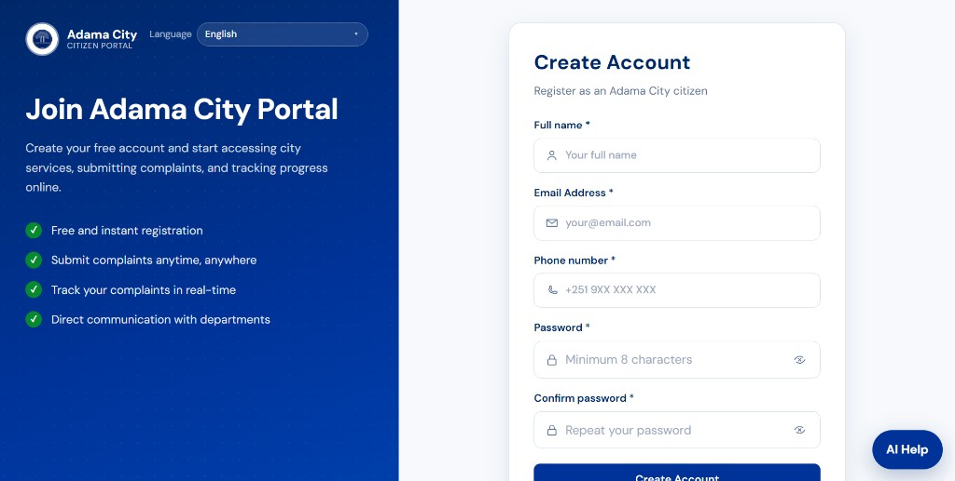
Figure 4.1: Public landing page — Quick Submit complaint, not a service-request form
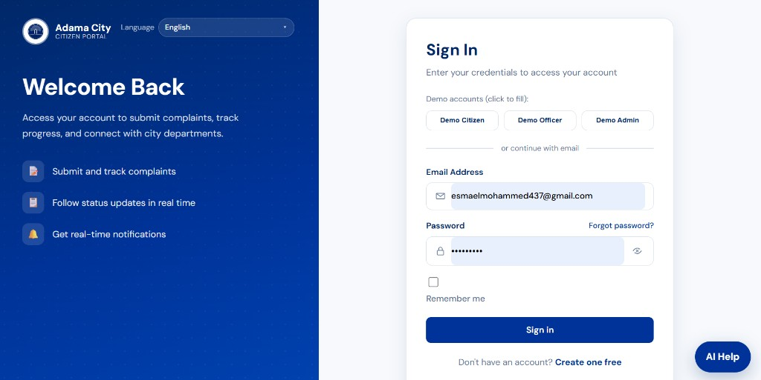
Figure 4.2: Create Account — register as an Adama City citizen
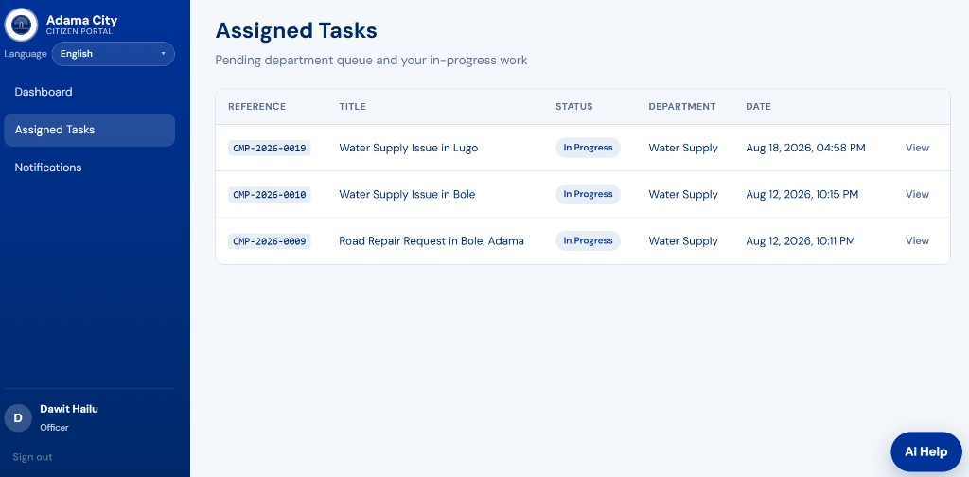
Figure 4.3: Sign In — demo Citizen / Officer / Admin and email login
4.1.2 Citizen Modules
After login, the citizen sidebar is Dashboard, New Complaint, My Complaints, Notifications, and Profile. The dashboard summarises complaint counts and links to tracking and alerts. New complaints use an Adama area dropdown, optional landmark, voice (Mic) on title/description, and AI assist. Pending rows on My Complaints show View and Edit. Opening Notifications marks items seen automatically (header shows 0 unread; there is no Mark as read button).
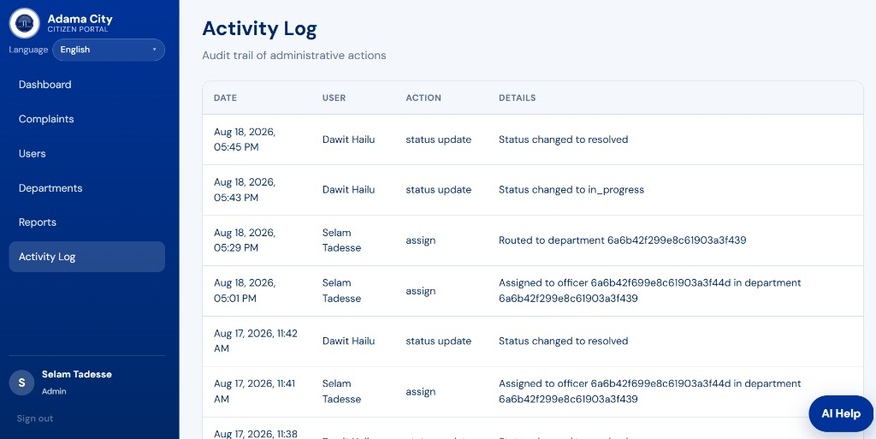
Figure 4.4: Citizen dashboard — Hello greeting, complaint totals, My Complaints and Notifications shortcuts
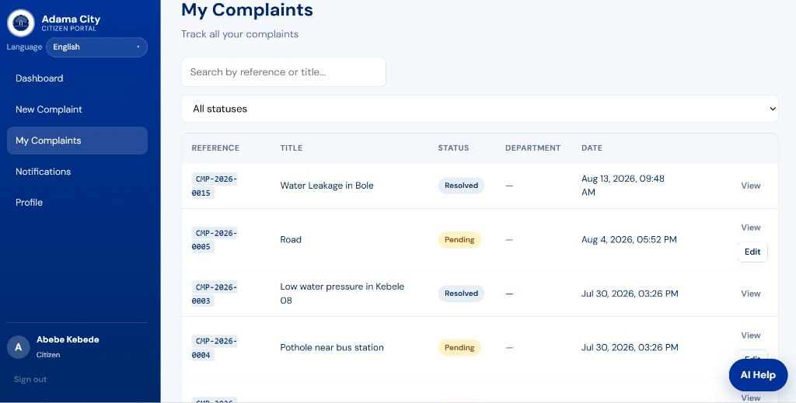
Figure 4.5: Submit Complaint — title, Adama location, landmark, description, Mic, and AI assist
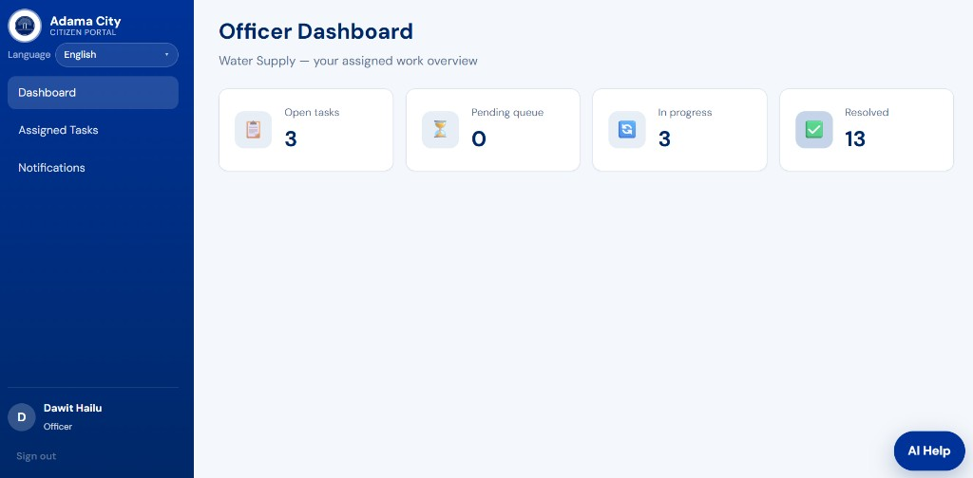
Figure 4.6: My Complaints — CMP- reference IDs, status badges, View, and Edit on pending items
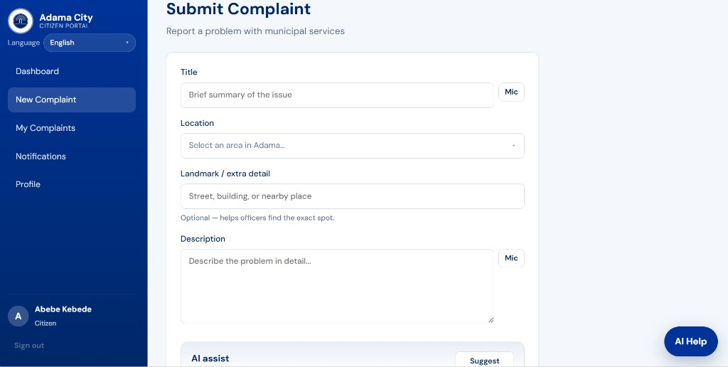
Figure 4.7: Citizen notifications — status updates for complaint CMP-2026-0015, 0 unread
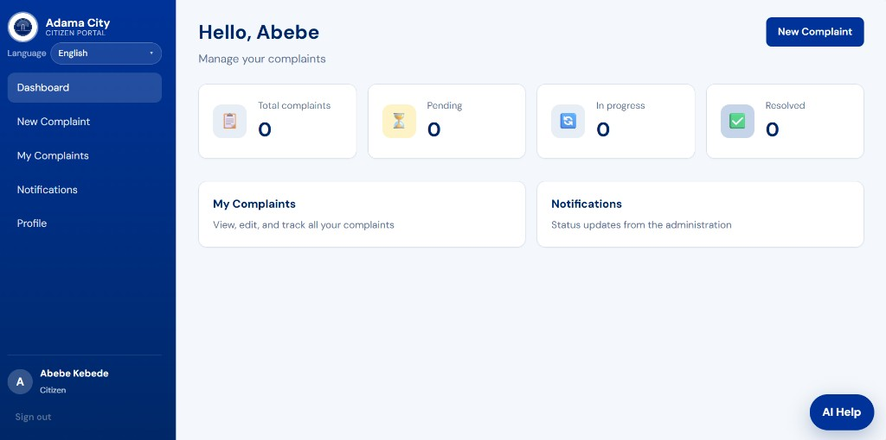
Figure 4.8: My Profile — editable name and phone; email and role are read-only
4.1.3 Officer Modules
The officer sidebar is Dashboard, Assigned Tasks, and Notifications. The dashboard is scoped to the officer’s department (e.g. Water Supply) with open / pending-queue / in-progress / resolved counts. Assigned Tasks lists department-queue and in-progress complaints (CMP- IDs) with View. Assignment alerts appear as New assignment cards and are marked seen when the page opens.
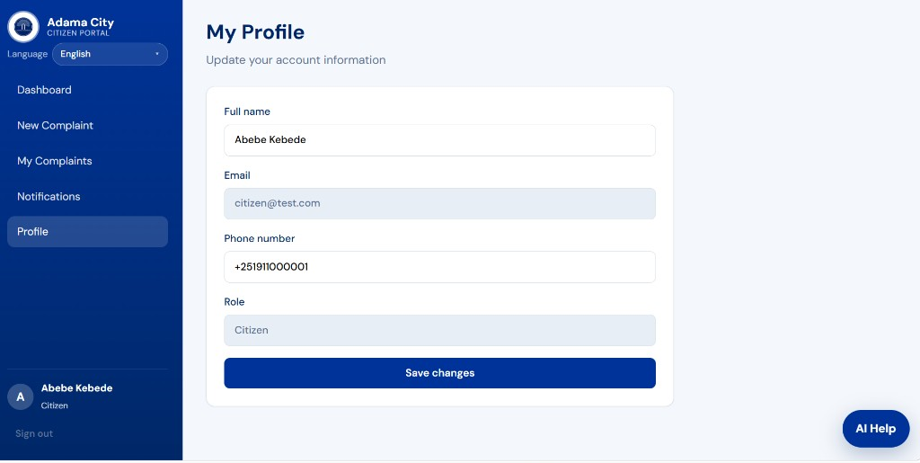
Figure 4.9: Officer dashboard — Water Supply work overview
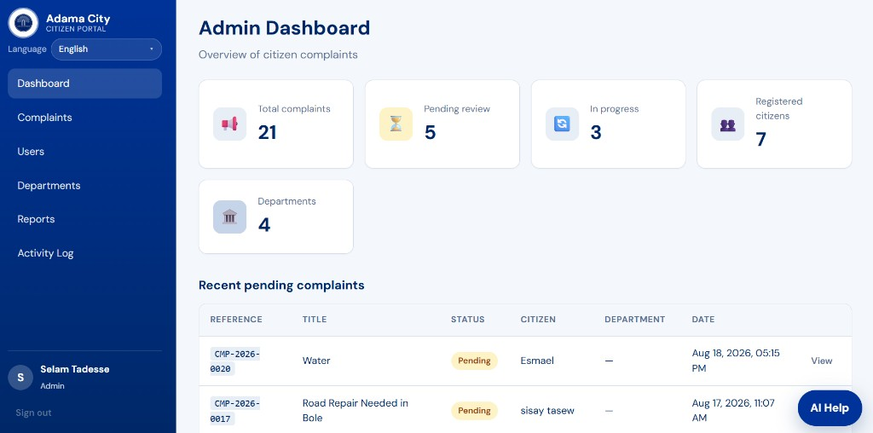
Figure 4.10: Assigned Tasks — pending queue and in-progress complaints
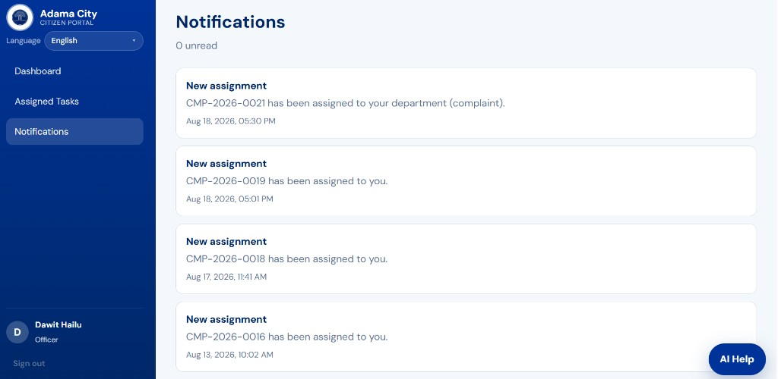
Figure 4.11: Officer notifications — new assignments (e.g. CMP-2026-0019), 0 unread
4.1.4 Administrator Modules
The admin sidebar is Dashboard, Complaints, Users, Departments, Reports, and Activity Log. The dashboard shows city-wide complaint totals and recent pending items. Manage Complaints searches and filters by status, then View opens assignment and status actions. User Management lists Citizen / Officer / Admin rows with department (officers) and Activate / Deactivate. Reports summarise totals by status and complaints by category. Activity Log records assign and status-update actions using complaint reference IDs plus department and officer names.
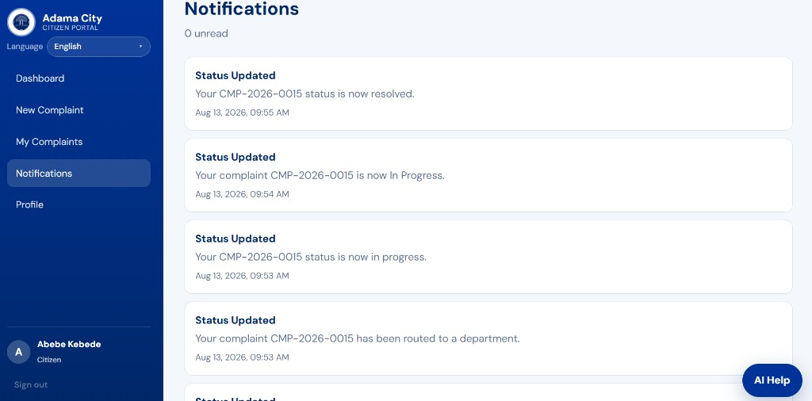
Figure 4.12: Admin dashboard — overview of citizen complaints and recent pending cases
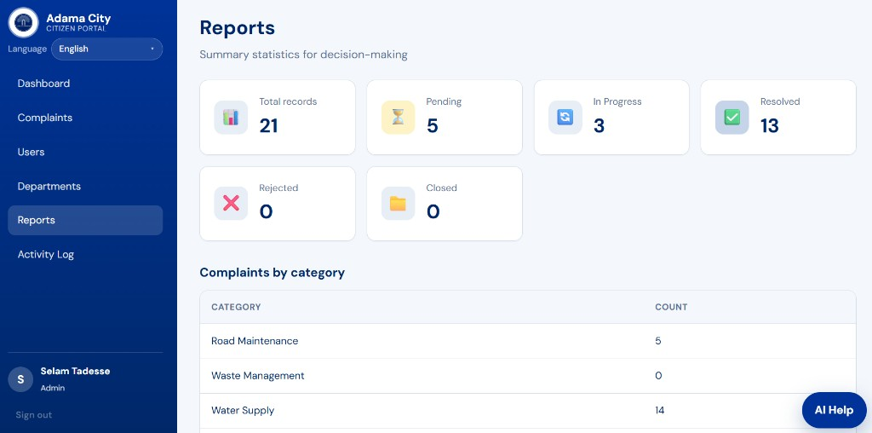
Figure 4.13: Manage Complaints — search, status filter, CMP- IDs, View
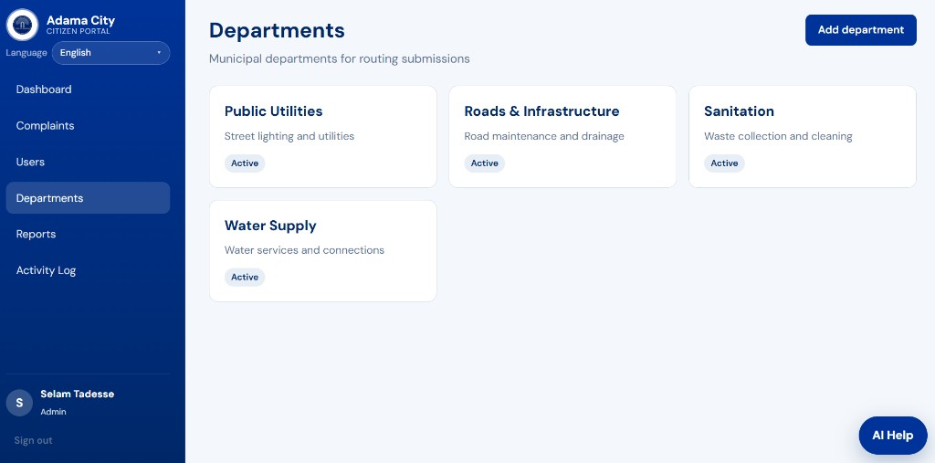
Figure 4.14: User Management — name, email, role, department, Active / Deactivate
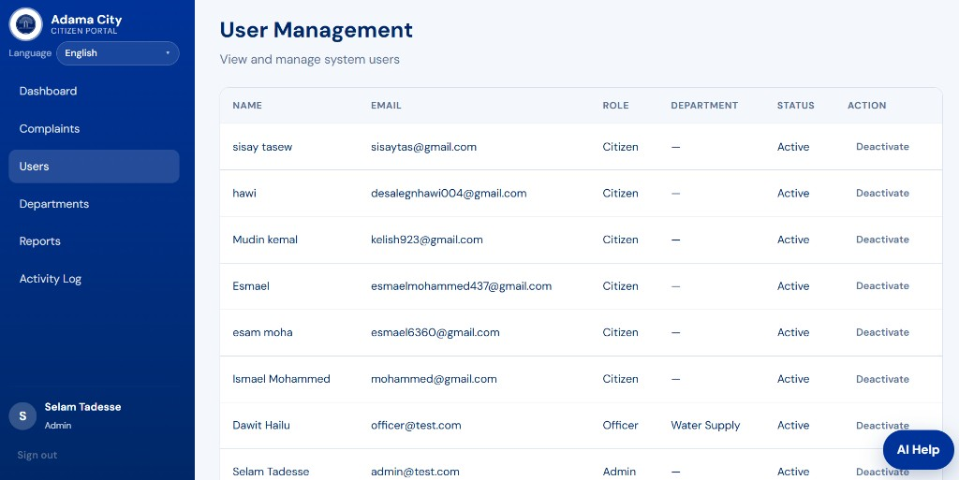
Figure 4.15: Reports — pending, in progress, resolved, rejected, closed, and complaints by category
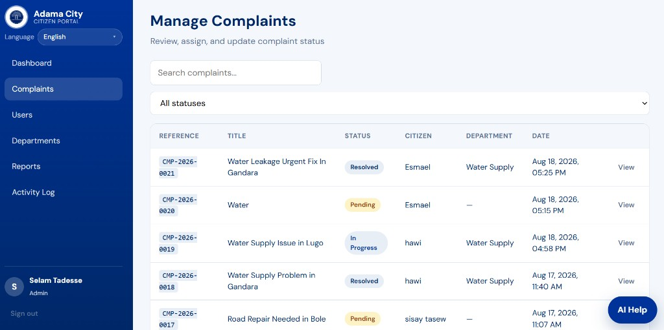
Figure 4.16: Activity Log — audit trail of assignments and status updates (new rows store names; older captured rows may still show IDs)
4.2 Discussion
The implemented results demonstrate that a centralized web portal can replace fragmented, paper-based complaint handling for Adama City Administration.
Alignment with objectives. Citizens can register, submit categorized complaints (Adama area, optional landmark, voice, and AI assist), edit pending cases on My Complaints, and track progress using CMP- reference IDs. Administrators manage complaints, users, departments, reports, and the activity log. Officers work from Assigned Tasks in their department. Notifications are marked seen when the Notifications page is opened. Optional AI Help is available across roles. These outcomes match the functional requirements defined in Chapter Two.
Transparency and accountability. Color-coded status badges (Pending, In Progress, Resolved, Rejected) and the activity log provide a visible audit trail. This directly addresses the earlier problems of weak tracking and limited accountability.
Role-based design. Separate dashboards for Citizen, Officer, and Admin enforce RBAC with JWT authentication. Citizens see only their submissions; officers see assigned tasks; admins see city-wide data and user/department controls.
Reporting for decision-making. The Reports module aggregates totals by status and category (e.g., Road Maintenance as a frequent complaint type in the sample data). This supports planning and departmental prioritization.
Remaining gaps. Some pending items remain unassigned until an administrator routes them (empty Department fields). Live SMS to real phones, GIS maps, and production-scale deployment remain future work. Sample/test titles in development data also indicate the need for continued validation and user training before full rollout.
Overall, the prototype confirms technical feasibility of the MERN-based solution and shows measurable progress toward transparent, trackable municipal service delivery.

4.3 Expected Benefits
4.3.1 For Citizens
• Easy online complaint submission
• Faster access to municipal services
• Transparency in service delivery
• Real-time status tracking and notifications
4.3.2 For Adama City Administration
• Improved centralized record management
• Better monitoring and departmental accountability
• Faster response to citizens
• Improved service quality through data-driven decisions
• Reports for planning and resource allocation

4.4 Expected Outcome
The project delivers a fully functional web-based system for managing citizen complaints. The system:
• Connects citizens, administrators, and department officers on one platform
• Provides transparent status tracking with audit history
• Generates reports for monitoring and decision-making
• Serves as a foundation for future enhancements (live SMS, mobile app, GIS)

4.5 Future Enhancements
• Live SMS notifications for status updates (Africa’s Talking scaffold exists)
• Native mobile application (Android / iOS)
• GIS integration for map-based complaint location
• Advanced analytics dashboard with charts, date filters, and export
• Full CRUD for users and departments; complaint delete; report export
• API pagination, rate limiting, and JWT refresh tokens
• Citizen feedback and satisfaction rating after resolution
• SLA tracking and escalation rules
• Integration with existing government systems

CHAPTER FIVE: CONCLUSION
This project designed and implemented a Web-Based Citizen Complaint Management System for Adama City Administration to replace fragmented, paper-based processes with a centralized digital portal.
The system meets the stated objectives by enabling citizens to register, submit categorized complaints, edit pending cases, and track status through unique reference numbers; enabling administrators to manage users and departments, assign work, update status, and generate reports; and enabling department officers to process assigned tasks and record resolution notes. JWT authentication and role-based access control protect resources according to user roles, while status history, in-app notifications, and email to real mailboxes improve transparency and accountability.
Implementation with the MERN stack demonstrated technical feasibility and practical value for municipal service delivery. Remaining limitations—such as live SMS, GIS mapping, and advanced analytics—are documented as future enhancements and do not prevent the current system from delivering the core complaint workflow.
In conclusion, the project provides a working foundation for transparent, trackable, and more efficient citizen–administration interaction in Adama City, and it supports further improvement as the host organization adopts and expands the platform.

References
1. FixMyStreet. Report, view, or discuss local problems. mySociety. https://www.fixmystreet.com/
2. IBM. Entity-Relationship Modeling. Software Engineering best practices.
3. MongoDB Inc. MongoDB Documentation. https://www.mongodb.com/docs/
4. Express.js. Web framework for Node.js. https://expressjs.com/
5. React. A JavaScript library for building user interfaces. https://react.dev/
6. OWASP. Authentication Cheat Sheet. https://cheatsheetseries.owasp.org/
7. Ethiopian Ministry of Innovation and Technology. Digital Ethiopia 2025 (e-governance context).
8. Sommerville, I. Software Engineering (10th ed.). Pearson — requirements and testing methodologies.
9. JWT.io. JSON Web Token Introduction. https://jwt.io/introduction
10. Adama City Administration. Municipal service delivery context (local organizational reference).

Document Revision History
Version | Date | Changes
1.0 | Initial | Original PDF proposal
2.0 | June 26, 2025 | Added ER diagram, timeline, literature review, methodology, testing, deployment, expanded DB schema, use cases, architecture, limitations, references; merged duplicate sections; clarified complaint vs service request
2.1 | July 28, 2026 | Aligned docs with implemented system: status transition rules, Atlas env, Vite/fetch, photo upload (2 MB), guest i18n, corrected FR/scope/limitations/test cases; removed unimplemented password-reset/Axios claims; updated use case diagram
2.2 | July 28, 2026 | Added Declaration and Acknowledgement sections
2.3 | July 28, 2026 | Expanded Table of Contents to include all subtopics
2.4 | July 28, 2026 | Added List of Acronyms
2.5 | July 28, 2026 | Added page numbers: Roman numerals for preface, Arabic for main body
2.6 | July 28, 2026 | Added Haramaya University cover page; personal details left blank for completion
2.7 | July 28, 2026 | Reorganized body into CHAPTER ONE–SIX with hierarchical section numbering
2.8 | July 28, 2026 | Added CHAPTER SIX: Results and Discussion with implementation screenshots; renumbered benefits to CHAPTER SEVEN
2.9 | July 28, 2026 | Condensed document into four chapters (Introduction; Requirements and Design; Methodology; Results and Discussion)
2.10 | July 28, 2026 | Aligned Table of Contents to academic style (dot leaders, hierarchy indent, Roman/Arabic page markers)
2.11 | July 29, 2026 | Added Abstract (Executive Summary); updated cover host-company / Practical Attachment wording; department name to Information Science
2.12 | July 29, 2026 | Added CHAPTER FIVE: Conclusion; updated Table of Contents
2.13 | August 18, 2026 | Aligned documentation with the implemented complaint-only system: Adama location dropdown, pending edit, EN/AM/OM app i18n, email + password reset, auto-seen notifications, optional AI sidecar; removed service-request workflow from scope and schema
2.14 | August 18, 2026 | Replaced Chapter Four result screenshots with current UI captures (landing Quick Submit, citizen/officer/admin complaint screens); removed leftover service-request result figures
2.15 | August 22, 2026 | Forced a results pass: Chapter Four figures stay on the current UI captures; README now includes the same screenshot gallery; activity log stores department/officer names instead of MongoDB IDs

End of Proposal

